**FINAL REPORT**

**Capstone Project - The Battle of Neighbourhoods**

**Introduction:**

To analyse the neighbourhoods of Thiruvananthapuram City in India to see the various types of restaurants been operating there

This will help for a an Hotel Businessman to know at which place in Thiruvananthapuram, what type of restaurant can be opened or start a new type of restaurant which is not currently serving at the city neighbourhoods.

**Data Section:**

For this project we need the following data:

* Thiruvananthapuram City data that contains list of Neighbourhoods along with their Taluk, State and Pincode
* Data source : https://www.indiatvnews.com/pincode/kerala/thiruvananthapuram/thiruvananthapuram-g.p.o.-
* Restaurants in each neighbourhood of Thiruvanathapuram City.
* Data source : Foursquare API
* Description: By using this API we will get all the venues in each neighbourhood. We can filter these venues to get only restaurants.

**Methodology:**

1. We begin by collecting the Thiruvanathapuram city data from the following link <https://www.indiatvnews.com/pincode/kerala/thiruvananthapuram/thiruvananthapuram-g.p.o.->

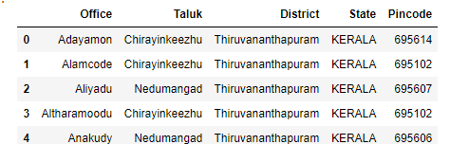

1. We will take only Offices belonging to Thiruvananthapuram Taluk.

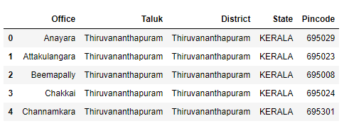

1. We will then add latitude and longitude using geopy

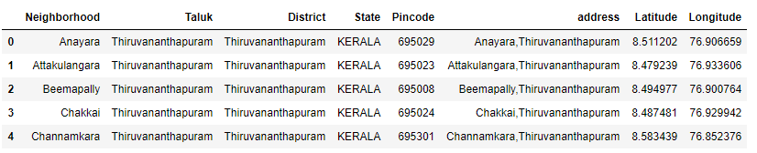

1. Next using Foursquare API, we will find the list of top 10 restaurants served in each area using one hot encoing 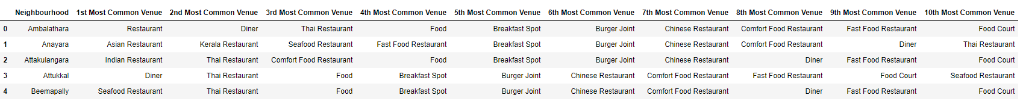
2. We will then cluster the neighbourhoods into 7 based on the similarity of cuisines served

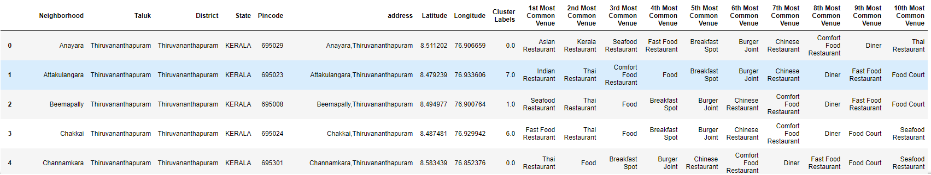

1. Finally, we will visualize the Neighbourhoods based on these 7 clusters

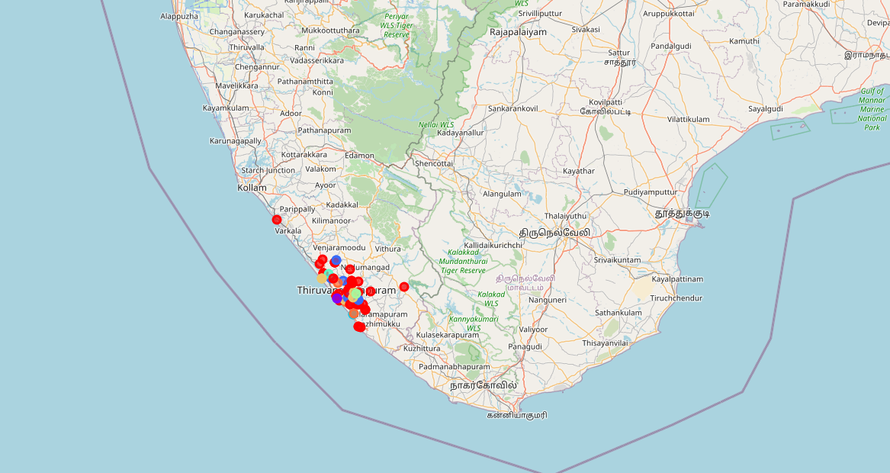

**Result:**



Answers: Based on the map generated with 7 clusters, a new hotel businessman can get an idea of what type of restaurant to start or any new type or to start a restaurant where currently restaurants are not being served.

Example, Lets think we want to start a restaurant at neighbourhood ‘Valiathura’, which is in Cluster 1 (violet in Map), so we can see the most type of restaurant served here is the SeaFood restaurant. So, Business man can opt for opening a Seafood restaurant here.

**Conclusion:**

There is always room for improvement and hence the above solution I have provided can also be improved for best results depending upon the data we have.

Like we can analyse neighborhoods by including Population data etc.